UNIT 9 HW

These are the same data from last week’s HW. Now, we are going to use them for simple linear regression.

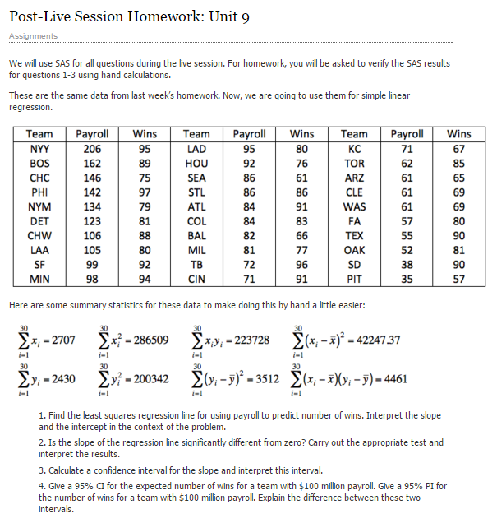

1)

a.

i. Find the least squares regression line using payroll to predict the number of wins. Interpret the slope and the intercept in the context of the problem. Show your work in finding the slope and intercept. You will need the above calculations. Do this by hand or using a basic calculator, but **NOT** by uploading the data into software. There are several equivalent formulations for the elements of the least squares regression line ( $\hat{β_{1}}$ and $\hat{β_{0}}$). Find one that utilizes the series (sums) above.

ii. Interpret the slope **AND** the intercept in the context of the problem.

b. Is the slope (only concerned with the slope here) of the regression line significantly different from zero? Carry out a 6-step hypothesis test to address this question. Use the above calculations to find the relevant statistics for this test. You will need to use SAS, R, the internet, a calculator, or integration to find the p-value and critical value, but do NOT upload the data to software. (One of the first 4 choices is suggested. ☺) Use α = 0.05.

c.

i. **BY HAND (**or basic calculator), calculate a 95% confidence interval for the slope. You should already have the pieces of the confidence interval (point estimate, multiplier, and standard error) from part 1b.

ii. Interpret the interval.

d. Verify your results (parameter estimates, test statistic for the hypothesis test of whether the slope equals zero, p-value for this same hypothesis test, and confidence interval for the slope) with SAS. Paste your code and relevant output below. Note what is the same or different.

2)

a.

i. Find the least squares regression line to assess the relationship between the math and the science score for the Test Data. We would like to be able to estimate a change in the mean math score for a one point change in the mean science score. (This should help identify the response and the independent variables.) Write your regression equation and paste your code and relevant output below. You should obtain the test statistics and other relevant statistics from R.

ii. Interpret the slope and the intercept in the context of the math and science scores.

b. Are the slope ***and intercept*** of the regression line significantly different than zero? Carry out a 6-step hypothesis test **for each** regression parameter to address this question (two different hypothesis tests). You should obtain the test statistics and other relevant statistics from R. Paste your code and any relevant output below. Use alpha = 0.01.

c.

**i. BY HAND**, calculate 99% confidence intervals for the slope and intercept (**two** separate confidence intervals). You may use point estimates, multipliers, and standard errors found from software, but put these pieces together to form confidence intervals by hand (or basic calculator).

ii. Interpret these intervals.

d. Verify your confidence intervals (for $β_{1}$ and $β_{0}$) with R and paste your code and relevant output below.

BONUS:

3) Repeat 1(d) using R.

4) Repeat 2(a)(i) and 2(d) using SAS.

5) We will cover this in Unit 10 ….

With reference to the baseball data …

1. Give a 95% CI (confidence interval) for the expected number of wins for a team with $100 million payroll. Use SAS or R.
2. Give a 95% PI (prediction interval) for the number of wins for a team with $100 million payroll. Use SAS or R.
3. Explain the difference between these two intervals.